**Optimizing Seaweed Farming through Predictive Analytics and Market Trend**

Consultancy Project (MANP098)

A Report to the Board of SoftSeaweed AS.,

By

ONWUCHEKWA IKECHUKWU CHARLES (3124840)

September 2023

**Executive Summary**

A viable option for environmentally friendly food production is seaweed farming. The goal of this project, which SoftSeaweed that is a Norwegian company founded in 2021, a leader in the seaweed farming sector with a strong network in the industry and a team comprising experts in IT, machine learning, engineering, seaweed farming, and business development, and I are working on together, is to increase seaweed farming production by strategically integrating predictive analytics and market trend analysis to lower production costs and boost revenue. This initiative aims to equip seaweed farmers with practical insights for wise decision-making while coordinating farming practices with market dynamics by utilizing open-source databases, farmer inputs, and weather forecasts. The analysis of regression models has made it possible to forecast the best times to harvest different kinds of seaweed. These models aid in maximizing yield and quality. Many studies utilizing regression models have identified a range of environmental factors affecting seaweed growth, including temperature, light availability, nutrient levels, and water quality. However, there is a need for deeper research into how these factors interact and how important each one is, particularly in light of the fact that the climate is changing and the dynamic nature of climate change necessitates further study in order to create adaptable techniques for seaweed farmers who must deal with erratic environmental conditions.

The project adheres to the CRISP-DM methodology, ensuring a comprehensive and structured approach to data mining and analytics. The phases encompass business understanding, data understanding, data preparation, modeling, evaluation, deployment, and revisiting business objectives. In the business understanding phase, the project design begins by identifying the core objectives, which involve optimizing seaweed farming to reduce production cost and increase revenue. Next, in the data understanding phase, relevant datasets were gathered and assessed, encompassing historical farm data and market trend information. The data preparation phase involved cleaning, integrating, and transforming this data into a suitable format for modeling. The modeling phase utilized predictive analytics techniques to build the actual model, leveraging historical data to forecast future farm conditions and market trends. Subsequently, in the evaluation phase, the model's performance was rigorously assessed using the coefficient of determination or Rsquared metric to ensure its reliability. Finally, in the deployment phase, the predictive model was implemented into the seaweed farming process, providing actionable insights that will enable farmers to make informed decisions that optimize their cultivation techniques in alignment with ever-changing market trends.

The modeling phase focused on developing predictive analytics models (linear regression) using machine learning algorithms, enabling the analysis of growth patterns and environmental impacts on seaweed production and its cost. The predicted model result is a good fit considering a coefficient of determination (R2) to be 98%. The predicted model pointed out the most production method used, its cost per sample on collected samples and market value with respect to the data set used. Based on the presented findings, this project has four key recommendations

Firstly, leveraging sensor data for the development of predictive models can revolutionize agriculture by enabling farmers to anticipate growth trajectories. This innovative approach empowers them to optimize cultivation techniques and make data-driven decisions, utilizing real-time insights for greater efficiency and productivity on their farms.

Secondly, designing an intuitive, user-friendly dashboard to provide farmers with real-time updates on farm conditions. This tool will be instrumental in delivering actionable insights, facilitating rapid interventions, and ultimately boosting productivity for agricultural operations.

Thirdly, integrating market trend analysis into the SoftSeaweed platform will enable farmers to align their production strategies with evolving consumer demands. This enhancement will significantly enhance their competitiveness in the market, as it empowers them to adapt and respond effectively to changing trends and preferences.

And the fourth is Creating a collaborative platform where farmers can come together to share their best practices and insights, fostering a sense of community-driven learning and improvement. This initiative encourages the exchange of knowledge among farmers, promoting a collective approach to continuous growth and development within the agricultural community. Not only that, ensuring that these solutions are user-friendly, enabling farmers of all expertise levels to harness the power of predictive analytics and market trend analysis.

The anticipated impact of this initiative transcends mere optimization. By deploying advanced analytics and perceptive market insights, this project holds the potential to reshape the very fabric of seaweed farming. It is poised to empower farmers to elevate their production processes, foster cost efficiency, and adeptly navigate the ever-evolving market landscape. SoftSeaweed's role in this endeavor solidifies its standing as an industry trailblazer, orchestrating the synthesis of technological innovation, sustainable practices, and economic growth. By embracing predictive analytics and market trend analysis, SoftSeaweed can revolutionize the future of seaweed farming, ensuring sustainability, profitability, and resilience in an evolving market landscape.

Table of Contents

Chapter 1 – Introduction 1

1.1 Background 2

1.2 Problem Statement 3

1.3 Description of Project aims and objectives 4

Chapter 2 - Literature Review 6

2.0. Introduction 6

2.1. Seaweed Market Size 7

2.2. Seaweed Farming Workflow 9

2.2.0. Introduction 9

**2.2.1. Increasing Revenue in Seaweed Farming** 12

2.3. Seaweed Farming Challenges 15

Chapter 3 – Methodology and Analysis 17

3.0. Introduction 17

3.1. Overview of Seaweed Farming Using Regression Model Analysis 22

3.2. Tools Used 24

3.3. Softseaweed Business Understanding 25

**3.3.1 Market Status** 25

**3.3.2 Opportunity** 25

**3.3.3 Threat** 26

3.4. Competitors 26

3.5 Softseaweed’s Current Business Situation 27

3.6. Data Processing 28

**3.6.1 Variable Selection** 29

**3.6.2 Data splitting** 29

**3.6.3 Linear Regression Model Design Process** 30

**3.6.4. Hyperparameter Tuning** 30

3.7. Model Evaluation 32

Chapter 4 – Results and Discussion 33

4.1. Introduction 33

4.2. Evaluation of Model Performance 33

4.3 Cost Benefit Analysis 38

Chapter 5 – Conclusion and Recommendation 40

5.1 Conclusion 40

5.2. Limitation 43

5.3. Recommendations 43

**5.3.1. Addressing key risk issues and sustainability issues** 44

**5.3.2. Key Risk Issues & solution:** 44

**5.3.3. Sustainability Issues & Solution:** 45

Chapter 6- References 47

6.1 Ethics approval (letter) Certificate Attached 52

# **Chapter 1 – Introduction**

1. **Introduction**

Growing seaweed is a lucrative industry with enormous potential for both farmers and investors. It is increasingly important for seaweed farmers to streamline their production procedures and keep up with industry trends as the demand for products made from seaweed rises. Predictive analytics and market trend analysis can be extremely useful in this situation for assisting seaweed farmers to increase yields, cut costs, and take advantage of new market opportunities.

At the forefront of this domain, SoftSeaweed comprehends the transformative potential of data and artificial intelligence in seaweed cultivation. Acknowledging the imperative of well-informed choices, operational efficiency, and sustainable expansion, SoftSeaweed presents its pioneering solution: the Seaweed Farm Management Software, accompanied by sensor arrays and AI-driven assessments. This multifaceted suite empowers farmers to navigate decisions judiciously, streamline their processes, and achieve enduring growth.

In a bid to push the envelope, SoftSeaweed is organizing a hackathon that seeks ingenious resolutions harnessing predictive analytics and market trends. The event converges students, researchers, and industry professionals, fostering a collaborative atmosphere to dissect the seaweed farming workflow comprehensively. By identifying avenues for enhancement and capitalizing on insights derived from data, the hackathon participants endeavor to augment SoftSeaweed's platform functionality exponentially.

In a bid to push the envelope, SoftSeaweed is organizing a hackathon that seeks ingenious resolutions harnessing predictive analytics and market trends. The event converges students, researchers, and industry professionals, fostering a collaborative atmosphere to dissect the seaweed farming workflow comprehensively. By identifying avenues for enhancement and capitalizing on insights derived from data, the hackathon participants endeavor to augment SoftSeaweed's platform functionality exponentially.

## **1.1 Background**

The production of sustainable food, environmental protection, and the creation of a variety of useful products are all possible outcomes of the burgeoning industry of seaweed farming. Seaweed farming provides a workable solution that takes advantage of marine ecosystems as the world faces increasing challenges with food security and reducing climate change.

The Norwegian business SoftSeaweed, which was established in 2021, has established itself as a pioneer in the seaweed farming industry. SoftSeaweed aims to give seaweed farmers the tools and knowledge they need to succeed in this changing market. The company has a strong network in the sector and a team made up of specialists in IT, machine learning, engineering, seaweed farming, and business development.

The Seaweed Farm Management Software and sensor packages are two of SoftSeaweed's key services. With the aid of this comprehensive system, farmers are given the tools necessary to efficiently launch, plan, and expand their seaweed farming operations. SoftSeaweed empowers farmers to fully utilize the potential of their farms and unlock significant economic value by integrating cutting-edge technologies like AI and predictive analytics.

The idea behind SoftSeaweed's strategy is based on the conviction that by streamlining seaweed farming procedures, farmers can increase yields while cutting costs. SoftSeaweed gathers a wealth of data via its digital platform and sensor technologies, including details from its own sensors, open-source databases, and direct input from seaweed farmers. Their AI system analyzes the data and offers insightful suggestions for improvement using this sizable dataset as its foundation.

Along with streamlining farm management procedures, SoftSeaweed understands how critical it is to incorporate market trends and data into their platform. Seaweed farmers can make well-informed choices regarding production planning, product diversification, and market entry strategies by comprehending market demand, pricing dynamics, and emerging opportunities. By utilizing market trends, SoftSeaweed makes sure that its customers are well-positioned to benefit from the anticipated 12 billion Euro seaweed market by 2030.

By utilizing the power of data, analytics, and market intelligence, SoftSeaweed hopes to unleash the unrealized potential of seaweed farming. By fusing technology, subject-matter knowledge, and creative thinking.

## **1.2 Problem Statement**

The seaweed industry is expanding quickly. In addition to producing seaweed products, big businesses like Unilever, PandG, Dupont, Orkla, and many others are starting to invest in the value chain to guarantee a supply of the raw materials. To meet the demand, seaweed farms must greatly expand. They must cut costs, take charge of the business, and boost ROI in order to accomplish these goals, and they can only do this with access to the data we will give them.

The majority of industrial customers need specific data from their farming sites. It is typically acquired by purchasing and installing sensors from various suppliers, which presents a number of difficulties. First of all, a lot of seaweed farmers are unaware of the data they should track, examine, and which suppliers are equipped with the appropriate sensors. They must invest time and money in the research phase, in speaking with sensor suppliers, in buying various sensor packages, and in integrating hardware and software.

The majority of the suppliers are from the oil and gas and aquaculture industries, and their products are not specifically designed for seaweed farmers. It implies that the majority of them require electricity and are not self-sufficient, that the cost of such commercially available solutions is very high, and that the choice of sensors is not the best for seaweed farmers. The data will be stored in various digital platforms if one selects a number of different suppliers and solutions, and vendors frequently lack sufficient knowledge of seaweed farming to provide analytics and reporting.

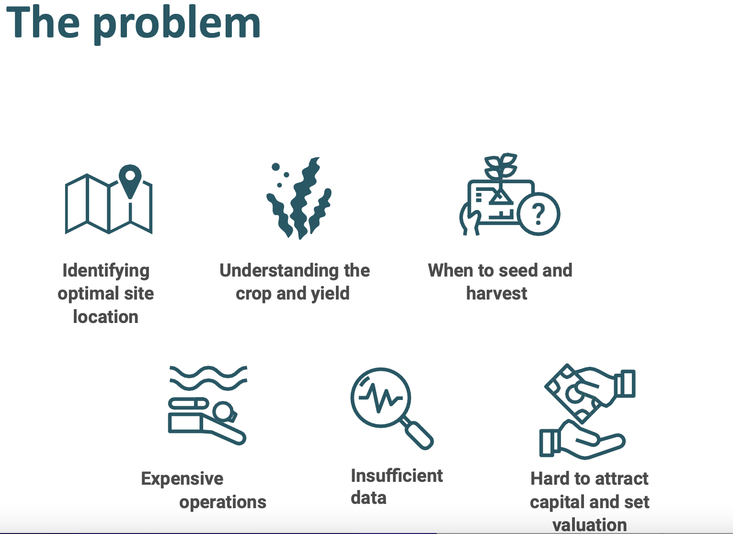

**Fig.1., Source**: Softseaweed Investor Presentation

## **1.3 Description of Project aims and objectives**

The project aims and objectives includes the following:

**Aims:**

* to integrate predictive analytics and market trend analysis to optimize the production of seaweed farms.
* to provide seaweed farmers with practical knowledge to aid in making wise decisions.
* to increase the operations' capacity for growth, financial success, and sustainability.
* to take advantage of market opportunities as they arise and match farming methods with changing consumer demands.
* to establish SoftSeaweed as a pioneer in offering cutting-edge solutions for the seaweed farming sector.

**Objectives:**

* To find opportunities for improvement and greater efficiency, analyze the seaweed farming workflow.
* Create a roadmap outlining the necessary steps, and resources needed for implementation in order to integrate predictive analytics and market trend analysis solutions.
* Create a thorough report highlighting the findings, recommendations, and suggested fixes.

# **Chapter 2 - Literature Review**

## 2.0. Introduction

The growing industry of seaweed farming, also referred to as seaweed aquaculture, has many positive effects on the environment, the economy, and society. In order to highlight seaweed farming's potential as a long-term solution for aquaculture and other uses, this review of the literature will investigate the current state of knowledge in that area. The review looks at seaweed farming's cultivation practices, environmental effects, financial aspects, and potential difficulties.

**Cultivation Practice**

A variety of cultivation techniques, such as longline systems, raft systems, and integrated multi-trophic aquaculture, are included in seaweed farming. Longline systems suspend ropes or lines with seaweed attached to them in the water column. Raft systems use platforms that float and encourage the growth of seaweed. Integrated multi-trophic aquaculture creates a system that benefits both parties by farming fish or shellfish alongside seaweed. All over the world, these techniques have been successfully applied (Renaud and Luong-Van, 2009).

**Environmental Impacts:**

Growing seaweed has potential advantages for the environment. The ability of seaweeds to absorb excess nutrients, which lowers eutrophication and reduces harmful algal blooms, is well known. Seaweed farms also serve as artificial reefs, increasing biodiversity and offering habitats for marine life. The introduction of non-native species, the release of surplus biomass, and interactions with wild populations are all potential ecological issues (Bird, K.T. and Benson, P.H. (1987).

**Economic Aspects:**

Growing seaweed offers a variety of lucrative business opportunities. Products made from seaweed are in high demand worldwide, including biofuels, fertilizers, and food additives. Commercial seaweed farming can help rural development and diversify the local economies of coastal communities. Nevertheless, issues with market expansion, infrastructure for processing, and production scaling up must be dealt with (FAO, 2012).

**Challenges and Future Directions:**

The widespread use of seaweed farming is hampered by a number of issues. The availability of suitable coastal areas, access to regulatory frameworks, technical know-how, and funding are a few of these. Further study is required to develop sustainable harvesting techniques, enhance seed supply, and optimize cultivation practices. To overcome these obstacles and realize the full potential of seaweed farming, cooperation between researchers, decision-makers, and industry stakeholders is essential (Kraan, 2013).

Finally, Growing seaweed has a lot of potential as a sustainable practice with many advantages. It is a desirable option for coastal communities and the aquaculture industry due to its potential for nutrient removal, habitat provision, and economic opportunities. However, for the successful and sustainable development of seaweed farming, careful management practices, ongoing research, and effective policy frameworks are required.

## **2.1. Seaweed Market Size**

According to a report by Mordor Intelligence Research & Advisory. (2023), The commercial seaweed market is divided into four categories: product type (red, brown, and green seaweed); application (food and beverage (hydrocolloids, thickeners, gelling agents, ice-cream stabilizers, and others); dietary supplements; pharmaceutical and medical; and other applications); and geography (North America, Europe, Asia-Pacific, South America, and Middle-East and Africa). For the aforementioned segments, the report provides market size and values in (USD Million) for the anticipated years. Below is the commercial seaweed market size in USD Billion:

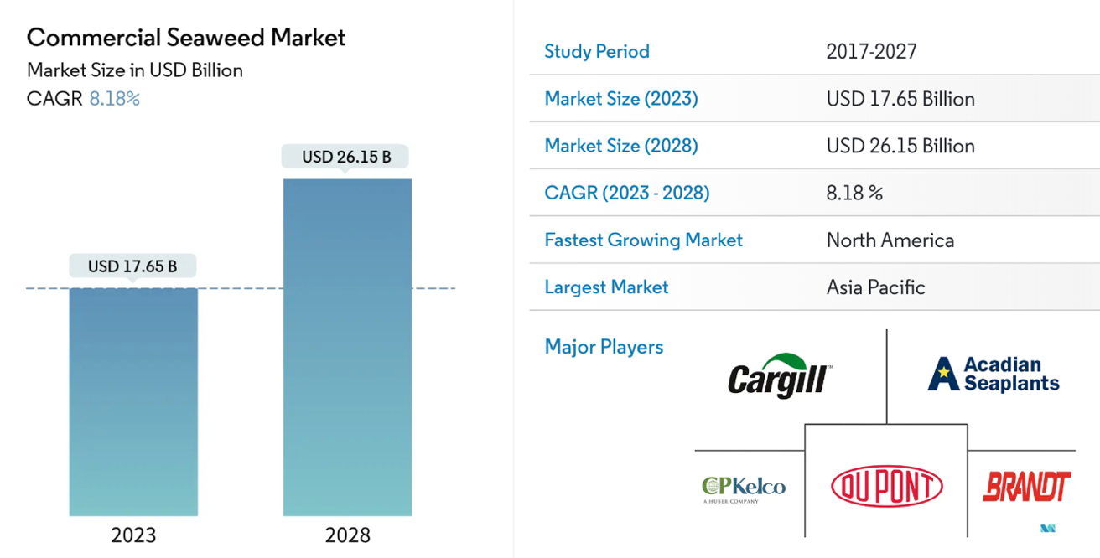

**Fig.2., Source**: Mordor Intelligence

The commercial seaweed market is driven by the useful and healthy qualities of edible seaweed. The food industry uses the majority of the seaweed that is produced commercially. Seaweeds are becoming more and more well-liked on a global scale as a staple food, flavoring agent, and nutrient-rich food item. They are also becoming more and more well-liked for their ability to aid in weight loss. Seaweeds are used as ingredients or eaten as foods because of their anti-microbial properties, which help with food preservation. Seaweed may be able to combat coronavirus, according to numerous reputable healthcare organizations, including the World Health Organization. This factor has simultaneously changed consumers' opinions of seaweed and raised their demand for it (Mordor Intelligence Research & Advisory, (2023).

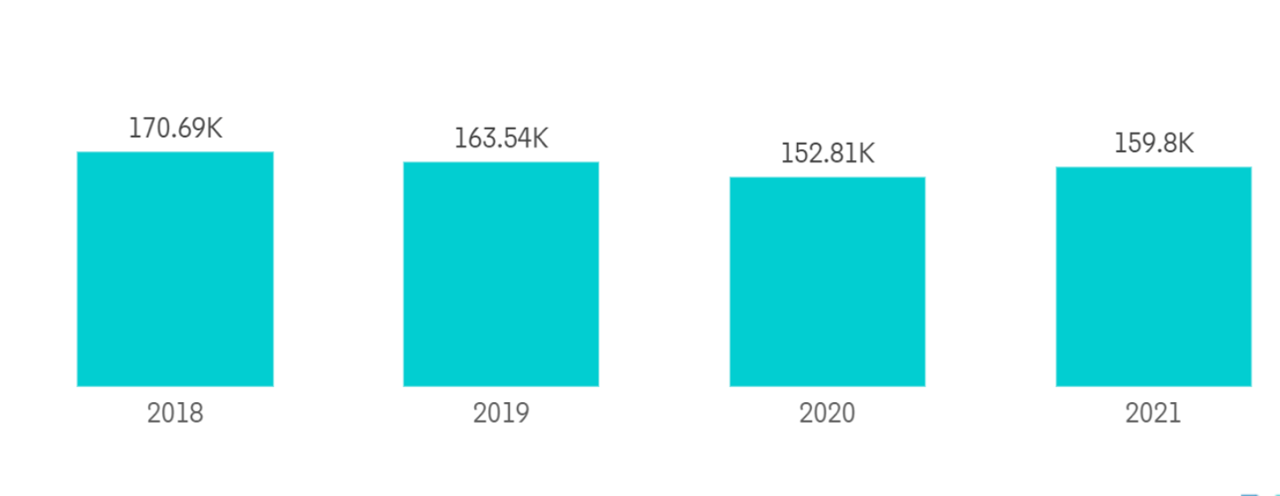

**Fig.3., Source:** Norwegian Directorate of Fisheries. **Commercial Seaweed Market:** Seaweed Harvesting in Metric Tons, by Volume, Norway, 2018-2021.

The largest commercial seaweed market is in Asia-Pacific. With the highest population in the world, the area has a larger market share. Additionally, the demand for commercial seaweed is significantly rising as a result of consumers' growing consciousness. The Republic of Korea, Japan, and China are the top three producers of seaweed. But seaweed production is now widespread across all continents. Seaweeds are used in a variety of dishes in China because they contain some nutrition. Seaweeds enhance food with a variety of textures, flavors, and aromas. As a result, the Asia-Pacific region is seeing an increase in seaweed demand.

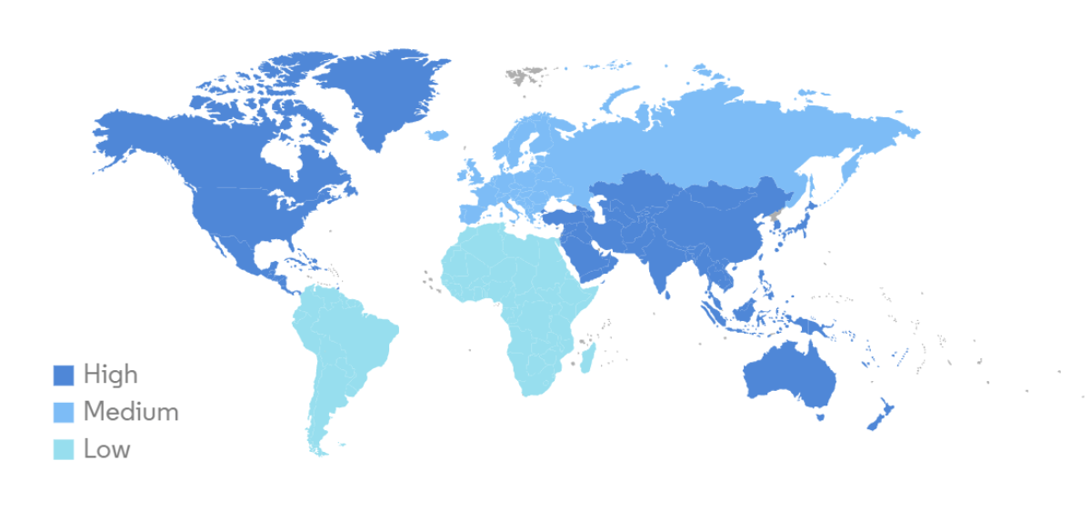

**Fig.4., Source:** Mordor Intelligence, **Commercial Seaweed Market:** Market Size (%), Global,2021

## **2.2. Seaweed Farming Workflow**

## 2.2.0. Introduction

Depending on the particular techniques and tools employed, the production process for seaweed can vary. A general workflow, however, is provided below, outlining the essential improvement needed:

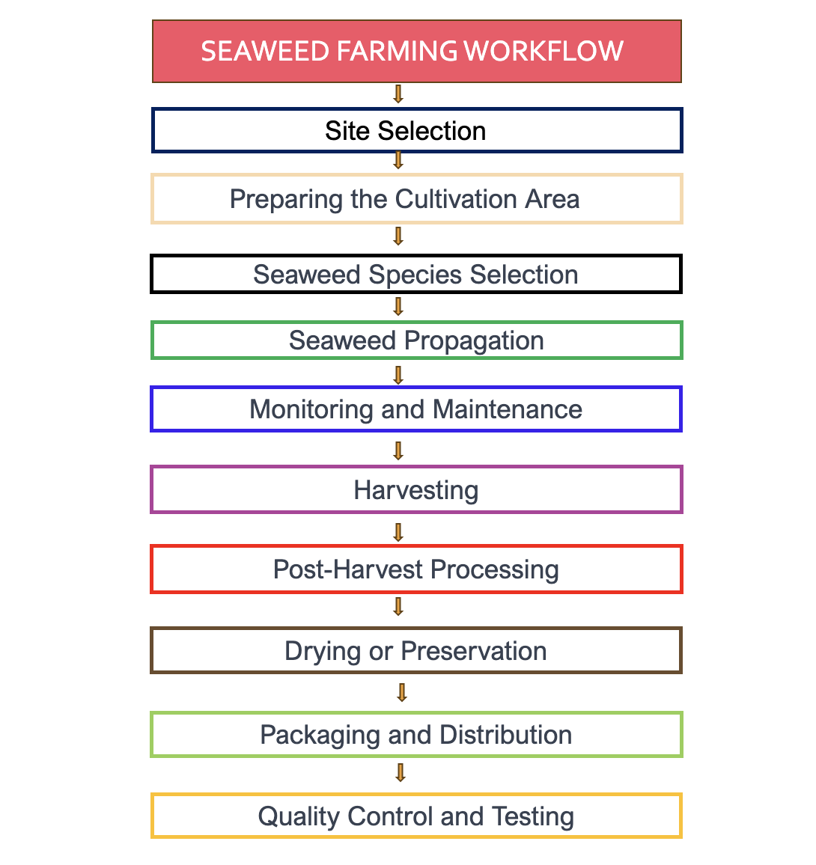

**Fig.5., Source:** Onwuchekwa Ikechukwu, Seaweed Farming Workflow

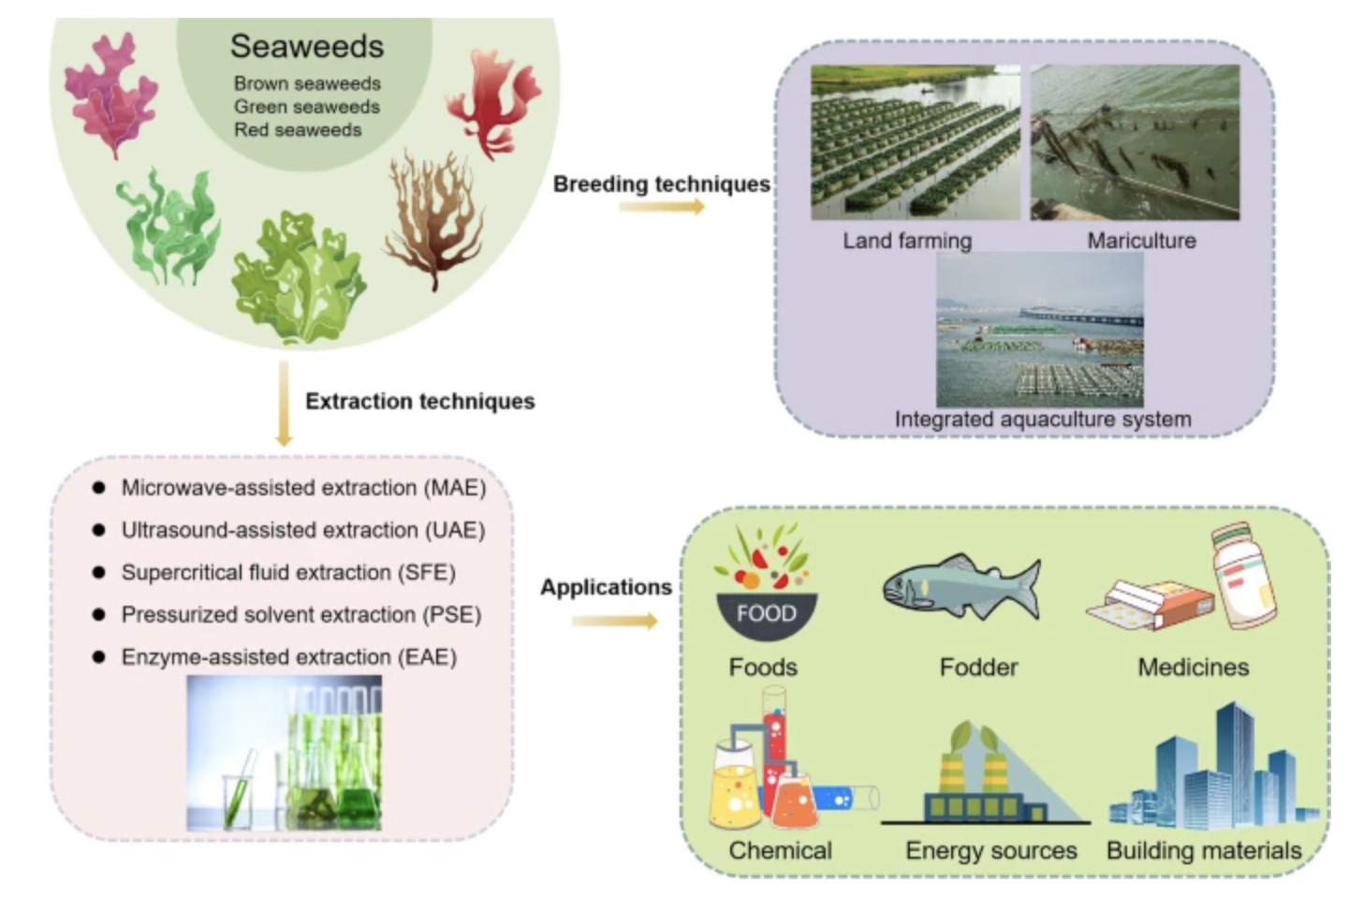

**Fig.6., Source:** Zhang et al., (2022). Overview of the global state of farming, extraction, and applications of seaweeds.

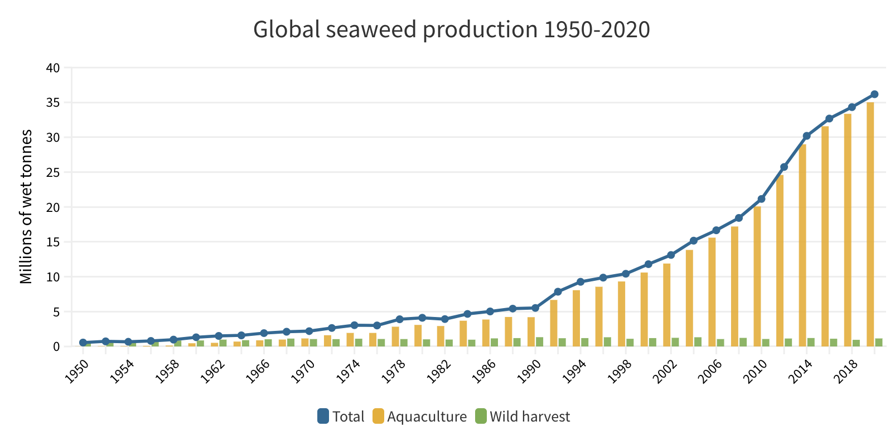

**Fig.7., Source:** FAO. 2022. Global aquaculture production 1950-2020 (FishStatJ).

When we talk about seaweed farming costs, we're talking about the costs involved in growing seaweed for trade. The expense of raising seaweed varies depending on the size of the operation, the cultivation methods used, the infrastructure needed, the labor force, the inputs used, and the post-harvest processing. Seaweed farming frequently involves the purchase of seedlings or spores, infrastructure installation and maintenance, cultivation equipment, labor, fertilizers or nutrient supplements, pest and disease management, harvesting tools, post-harvest processing and drying equipment, packaging materials, transportation costs, and marketing costs

For their businesses to be profitable, seaweed farmers must accurately estimate and manage their costs. Farmers can increase profitability and sustainability by identifying areas where costs can be minimized or optimized through the use of cost analysis.

Farmers can think about implementing the following tactics to lower costs in seaweed farming through the following:

**Efficient Seedling/Spore Usage:** To reduce waste and increase yield per unit area, ensure proper spacing and attachment methods for seedlings or spores. (Troell et al., 2009)

**Nutrient Management:** Use precise nutrient management techniques to reduce costs, avoid overusing fertilizers, and lessen any negative effects on the environment. Chopin, T., et al. (2017).

**Energy and Water Conservation:** Reduce the amount of electricity use by using energy-efficient water circulation systems, like passive flow systems or low-energy pumps. Use water sparingly by reusing or recirculating it. Neori, A., (2007).

**Sustainable Infrastructure and Equipment:** Choose cost-effective infrastructure options, such as inexpensive floating systems or locally sourced materials, to reduce capital expenditure. Gentry, R. R., et al. (2017).

To lower individual investment and maintenance costs, consider partnerships or shared infrastructure arrangements with nearby farmers. Gentry, R. R., et al. (2017).

**Financial Management and Analysis:**

To find opportunities for cost reduction and optimization, keep accurate financial records and frequently analyze the costs related to various aspects of seaweed farming. Liu, F., et al. (2021).

**Government Support and Funding:** To ease financial strains and support cost-cutting initiatives, look into government funding options such as grants and funding opportunities that are specifically targeted at seaweed farming.

**Integrated Pest and Disease Management:** Implement preventive measures, such as regular monitoring, proper farm hygiene, and biological control methods, to reduce reliance on chemical interventions and associated costs. Ridler, N., et al. (2007).

Implementing these strategies, combined with site-specific considerations and farmer expertise, can help seaweed farmers reduce costs and improve the overall profitability of their operations.

### **2.2.1. Increasing Revenue in Seaweed Farming**

**Introduction**

According to Polaris Market Research & Consulting LLP. (2023),” the global seaweed protein market size/share is expected to reach USD 481.82 Million in 2022. The study further indicates that the market will grow at a compound annual growth rate (CAGR) of 11.3% and is projected to touch USD 1,407.41 Million By 2032.” As consumers and food producers look for wholesome, sustainable protein sources, the world's hunger crisis is boosting the market for seaweed proteins. The image below shows the seaweed protein market size, by region 2019-2032(USD Million).

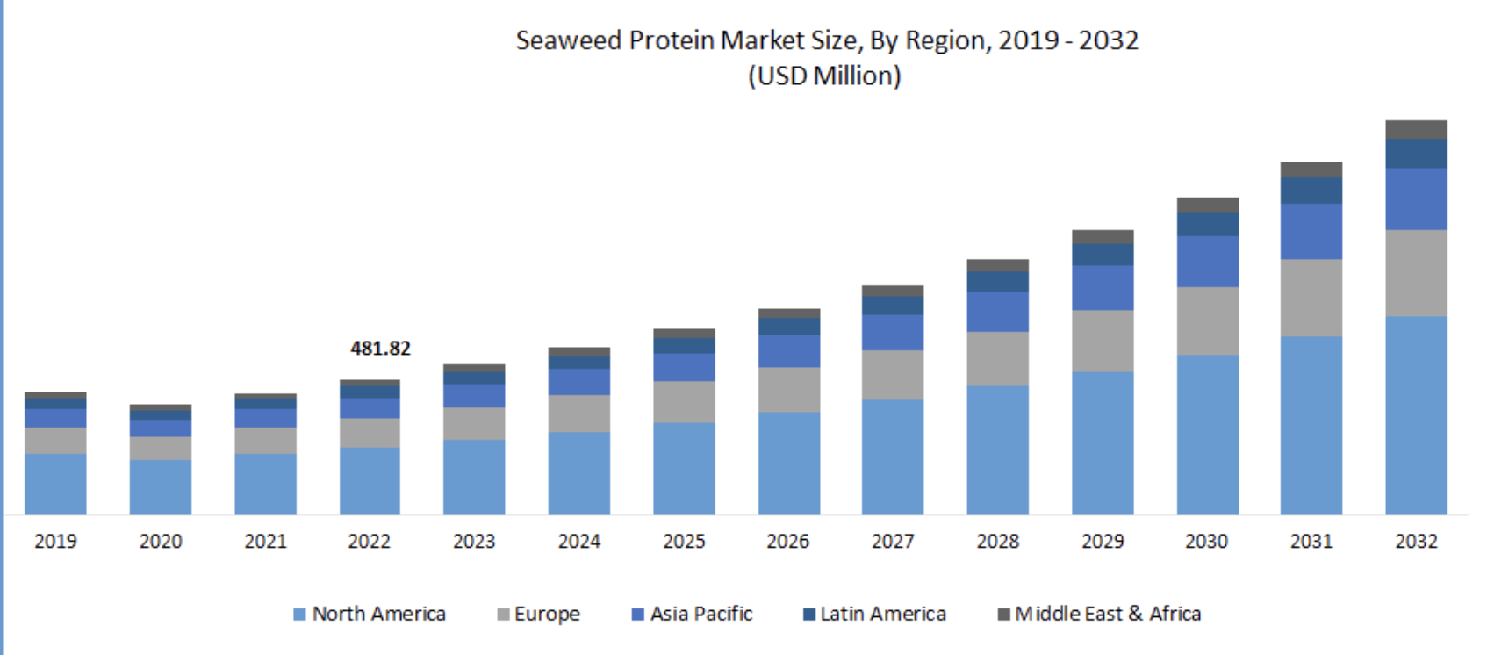

**Fig.8., Source**: Polaris Market Research. (2023), Seaweed Protein Market Size, By Region, 2019 - 2032

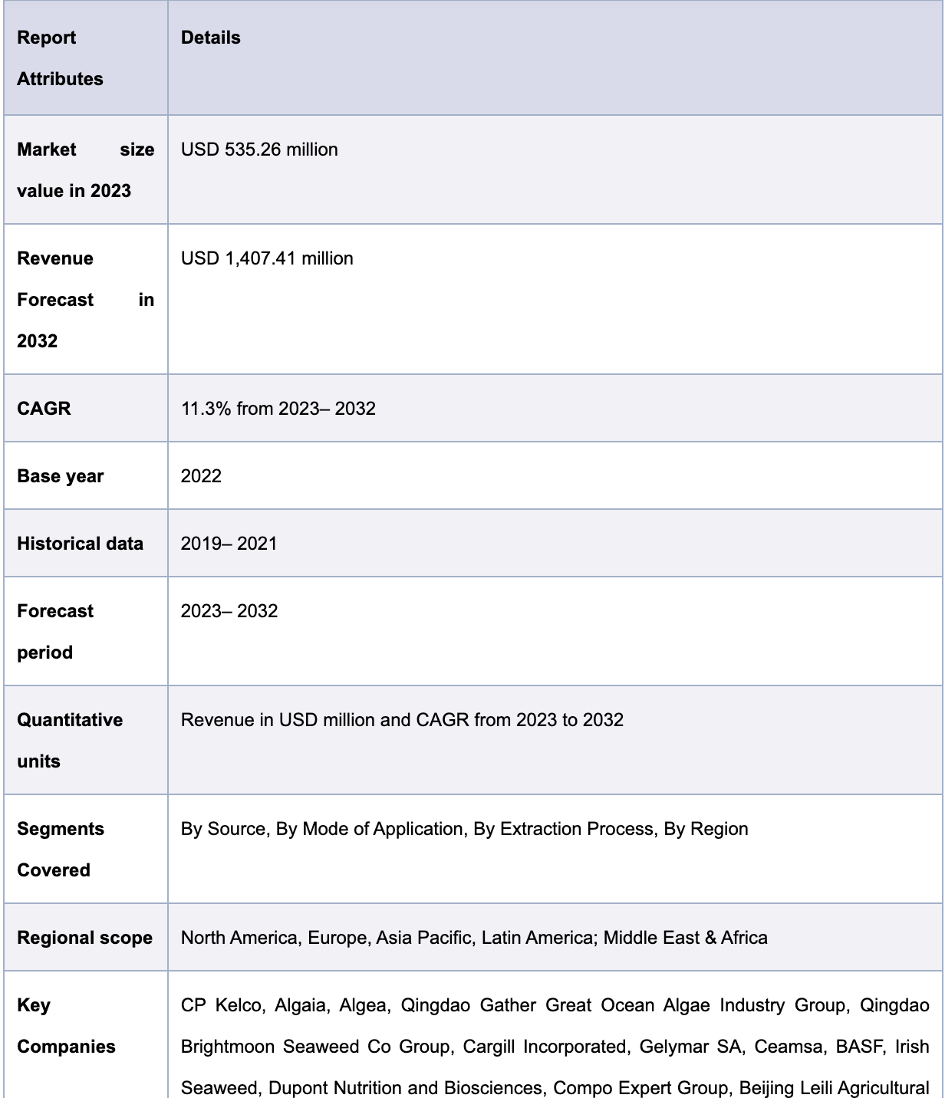

**Fig.9., Source:** Polaris Market Research. (2023)., Seaweed Protein Market Report Scope

Following the growth of the seaweed market, the revenue for seaweed market can be increased considering the following strategies:

**Market Differentiation and Product Development:** Create distinctive seaweed goods or value-added derivatives that meet certain customer requirements and preferences.

To diversify the product line and take advantage of niche markets, look into new product formats like seaweed snacks, seasonings, or specialty ingredients. Hughes, A. D., et al. (2019).

**Market Expansion and Direct Sales:** Target new markets, such as neighborhood eateries, specialty food shops, or retailers of health foods, to increase the customer base.

Create direct sales channels, like websites or farmers' markets, to sell seaweed products to customers directly, cutting out middlemen and boosting profit margins. Grand View Research. (2021).

**Branding and Marketing:** For seaweed products, create a distinctive brand identity that highlights their special traits, health advantages, and sustainability.

Spend money on marketing and advertising campaigns to educate target customers and generate interest in seaweed products.

**Collaboration and Value Chain Integration:** Develop co-branded or value-added seaweed products in conjunction with other companies in the value chain, such as food processors, eateries, or manufacturers of health products.

Look into joint ventures to supply seaweed as a raw material to extract or seaweed processing businesses. Chopin, T., et al. (2017)

By putting these tactics into practice, seaweed farmers can raise the potential revenue of their seaweed farming operations and take advantage of the expanding market for sustainable, wholesome, and value-added seaweed products.

## **2.3. Seaweed Farming Challenges**

Even though it is a promising industry, seaweed farming has its difficulties. Here are a few typical difficulties that arise when growing seaweed according to (Neori et al., 2004):

**Environmental Impact and Siting:**

To prevent negative environmental effects like obscuring underwater habitats and changing local water conditions, seaweed farms must be strategically placed. To reduce possible harm, careful site selection is crucial.

**Biotic Interactions:**

The growth and health of farmed seaweeds can be impacted by herbivore predation and competition with native species. To avoid damaging effects on biodiversity, it is essential to maintain the balance of local ecosystems.

**Disease and Pests:**

Similar to land-based agriculture, seaweed farming can experience problems with pests and diseases that spread and harm crops, causing financial losses.

**Harvesting Techniques:**

For high-quality seaweed production to be achieved, effective and sustainable harvesting methods must be developed. The economic viability of seaweed farming can be affected by labor-intensive harvesting techniques.

**Market Development:**

Consumer demand must be generated and the market for seaweed products must be expanded through marketing and educational initiatives. It can be difficult to create products that are both innovative and enticing.

**Infrastructure and Technology:**

In the difficult marine environment, building and maintaining appropriate infrastructure can be expensive. To improve operations, farm design and technology innovations are required.

**Seasonality and Climate Change:**

Seasonal variations and climate change frequently have an impact on seaweed growth. Farm productivity may be impacted by changes in water temperature, ocean acidification, and storm activity.

# **Chapter 3 – Methodology and Analysis**

## 3.0. Introduction

The data and procedures that were used to plan the experiment and build the models are discussed in this section and the methodology and analysis used in this report was executed using the CRISP-DM approach and is shown below:

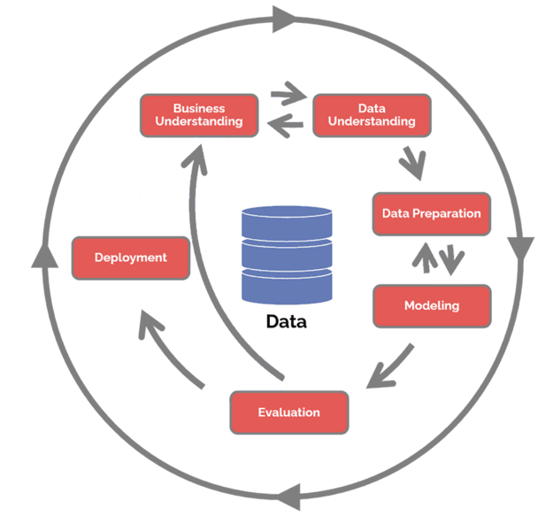

**Fig.10., Source:** (Hotz, 2023)

Applying the CRISP-DM methodology to explain the project of optimizing seaweed farming and production through predictive analytics and market trend is shown below:

1. **Business Understanding:**

The business understanding in this context is to optimize seaweed farming and production for SoftSeaweed's customers by leveraging predictive analytics and market trends. Some key questions to address are:

* What problems and difficulties do farmers of seaweed face?
* How can farmers scale their operations and lower production costs with the help of SoftSeaweed's platform?
* What kinds of information can be gathered and examined to offer farmers useful insights?

1. **Data Understanding / Description of Data**

The data to be used for this project comes from a variety of sources, all of which are essential for the evaluation and improvement of seaweed farming output. The data source is shown below:

A. Open-Source Databases:

In addition to the sensor data, the project will leverage relevant oceanographic, ecological, and maritime open-source databases. These databases contain valuable information about oceanic conditions, nutrient levels, tidal patterns, and other environmental factors that impact seaweed growth. Integrating this data with the sensor data allows for a comprehensive analysis of the farming environment and its effects on seaweed production. Also, access to a variety of information, including scientific studies, research findings, and industry reports, is made possible by open-source databases. They can be used to learn about different types of seaweed, how to cultivate them, and best practices. Some of the open-source data for this report can be gotten from:

1. Global Biodiversity Information Facility (GBIF): This access to biodiversity data from around the world, including information on seaweed species distribution (Lavery, P. S., et al. (2020).
2. The FAO Fisheries and Aquaculture Department: Provides a range of reports and publications on aquaculture and seaweed farming techniques.

B. Weather Forecast Data:

Weather forecasts play a crucial role in optimizing farming operations. SoftSeaweed collects weather forecast data, encompassing approximately 30 parameters, which include temperature, precipitation, wind speed, and solar radiation. This data helps farmers anticipate and adapt to changing weather conditions, plan harvests, and optimize resource allocation. (Mohseni, E. and Tang, W. (2021)

By combining the above data sources, the project aims to create a comprehensive dataset that enables predictive analytics and market trend analysis. The sensor data provides real-time insights into the farm conditions, while open-source databases offer broader environmental context. Weather forecast data helps in making informed decisions related to farming operations.

Finally, development of predictive models, practical insights, and well-informed suggestions for enhancing seaweed farming production will be made possible by the integration and analysis of these various data sources. This all-encompassing strategy, utilizing different data types, is essential for giving farmers a thorough understanding of their farming environment and equipping them to make data-driven decisions for increased productivity and profitability.

Farmers can learn more about the ideal conditions for seaweed growth and choose the best cultivation techniques by gathering and analyzing sensor data (Beca-Carretero, P., et al. (2020) & Buck, B. H., & Buchholz, C. M. (2004).

1. **Data Preparation / Data Manipulation Plan**

The data manipulation tool used for this report is the orange software, which offers built-in, automated data manipulation functions, such as, data cleaning, mapping, aggregating, or storing. The steps listed below will be used to archive the data mining objective:

* **Data Collection:** The first step will be to source for relevant data from open-source databases with relevant oceanographic, ecological, and maritime information that could be integrated into SoftSeaweed's platform. And also, source for weather forecast data, Export data about seaweed sold to EU and US etc.
* **Data Preprocessing:** To ensure the data's quality, it will be necessary to preprocess the data after it has been collected. To do this, the data must be standardized and normalized as well as cleaned up of duplicates, missing values, and outliers.

Next, it will be to explore the data to look for trends and connections between variables. To understand the data and its distribution, various statistical methods and visualizations will be used.

* **Data Analysis:** In this step, make use of innovative business analytics and data science techniques to analyze the data and find trends, patterns, and insights that will help us better understand how to Optimize Seaweed Farming and Production through Predictive Analytics and Market Trend**.**
* **Model Development:** Based on the data analysis's findings, create a predictive model to pinpoint potential areas for enhancement optimization of seaweed farming. Using historical data, the model will be examined and verified.
* **Interpretation of Results:** Finally, interpret the model's findings and make suggestions on Optimize Seaweed Farming and Production through Predictive Analytics and Market Trend**.** These suggestions will be based on the knowledge discovered through data analysis and the predictive model.

1. **Modelling:**

Regression model was used for this project. Specific tasks in this phase include:

* Selecting appropriate modeling techniques, such as time-series forecasting or regression analysis, based on the nature of the data and business objectives.
* Training and validating the models using historical data to ensure their accuracy and reliability.
* Assessing the impact of various variables on seaweed farming and production costs.

Regression modeling is a statistical method used in data analysis and machine learning to represent the relationship between a dependent variable (also called the response variable or outcome) and one or more independent variables (also called predictor variables or features). In order to predict the value of the dependent variable based on the values of the independent variables, regression modeling aims to develop a mathematical equation that best captures the relationship between the variables.

Although there are various types of regression models, linear regression is the most popular because it assumes a linear relationship between the dependent and independent variables. By minimizing the difference between the predicted values and the actual values, linear regression seeks to find the best-fitting line (or hyperplane in multiple dimensions) through the data points. According to (Beers, 2023), the general form of each type of regression model is stated below:

1. Simple Linear Regression: A simple model that establishes a linear relationship between the predictors and continuous outcomes. In linear regression, the model is represented by a linear equation:

y = β0 + β1 * x1 + β2 * x2 + ... + βn * xn

where y is the dependent variable, β0 is the intercept, xi represents the ith independent variable, and βi is the coefficient (slope) associated with xi. The goal is to estimate the coefficients that best fit the data.

B Multiple Regression: Extending linear regression to include multiple predictors to capture more complex relationships. In linear regression, the model is represented by a linear equation:

**Multiple Linear Regression:**

Multiple linear regression extends simple linear regression to include multiple independent variables. The model's equation is expressed as:

Y = β0 + β1X1 + β2X2 + ... + βnXn + ε

Where:

Y is the dependent variable (e.g., seaweed yield).

X1, X2, ..., Xn are the independent variables (e.g., temperature, light, nutrient levels, etc.).

β0, β1, β2, ..., βn are the coefficients representing the impact of each independent variable on the dependent variable.

ε is the error term, accounting for the variability not explained by the independent variables.

## **3.1. Overview of Seaweed Farming Using Regression Model Analysis**

Several prediction and analysis studies on seaweed farming have been carried out by different researchers all over the world. The study on the production efficiency of seaweed farming in Tarakan North Borneo by (Banyuriatiga et al. (2017) was carried out to determine the factors that influence the production of seaweed in Tarakan and determine the level of technical efficiency obtained by seaweed farmers in Tarakan. In this research, a multiple linear regression model was used to find and measure the influence of the independent variable on the dependent variable. The equation used is shown below

Ln Y = Ln a + β1 Ln X1 + β2 Ln X2 + β3 Ln X3 + β4 Ln X4 + β5 Ln X5 + β6 Ln X6 + β7 Ln X7 + β8 Ln X8

+ dD + e

This research was conducted using two types of data source, a primary data which was obtained directly from seaweed farmers in Tarakan and a secondary data supporting data originating from agencies or stakeholders associated with the research. The level of technical efficiency was done using the Frontier application and the technical efficiency on seaweed farming was calculated using the following assumption:

* If the value of technical efficiency is equal to one, then the use of inputs in farming seaweed is efficient.
* If the value of technical efficiency is not equal to one, then the use of inputs in farming seaweed is not efficient.

According to the analysis carried out, the model's goodness of fit was determined using R-squared, which indicates the proportion of variation in seaweed yield that can be explained by the independent variables in the model. As the percentage of the dependent variable explained by the independent variable rises, regression models with higher adjusted R2 values are better. According to the analysis, the adjusted R2 value is 0.892, meaning that 89,2 percent of the variation in the dependent variables can be accounted for while the remaining 10,8 percent is explained by other variables outside the model.

The analysis using the F test yielded the values 92,175 and 2,61 for Fcount and FTable, respectively, with a probability of 0,000, indicating that F count was greater than F Table at the level of significance of = 1%. This demonstrates how various independent factors have an impact on Tarakan's seaweed production. Then, using a t-test, one can determine how changes in the independent variable affect the dependent variable.

1. **Evaluation & Deployment:**

According to the review of regression modelling applied in other studies, this project utilized a variety of data visualization, exploration, preprocessing, and modeling techniques, the orange software application was used to create the model. It is especially helpful for associative rule mining of numbers, text, and even network analysis, in addition to becoming handy in machine learning.

After a successful evaluation with cross-validation, random sampling, and test on train data where the involved hyperparameters will be used methodically, the model results will be interpreted. For the model evaluation, the following three metrics are important:

1) R Square/Adjusted R Square (R2) (where R is the correlation between output and target)

2) Mean Square Error (MSE) / Root Mean Square Error (RMSE)

3) Mean Absolute Error (MAE)

Since R squared (R2) explains the number as a percentage of the output variability, it will be used for model interpretation. If the reported model score falls between 0 and 1, the performance of the model is considered to be good. A scattered plot can be used to further interpret the relationship between two variables.

## **3.2. Tools Used**

The right tool selection is essential for maximizing the potential of data analysis and predictive analytics in the field of seaweed farming optimization through regression modeling. This section presents a variety of potential tools that has been used by beginners to more specialized platforms. The tools used for this project include:

1. **Orange:**

This is a data mining tool that will be used for data exploration, building predictive model through a visual interface, and creating an interactive visualization. Orange is an open-source data visualization and analysis tool that was used for data mining, machine learning, and interactive data visualization. It provides a user-friendly interface that allows users to load datasets, perform various data preprocessing tasks, create and compare machine learning models, and visualize results.

1. **Excel:**

This is a visualization tool that will be used for statistical summary (calculation) of the data set, some data cleaning and for creating basic charts. Excel was used to clean, format, and preprocess data before feeding it into machine learning algorithms. This involves tasks such as handling missing values, removing duplicates, and transforming data.

1. **Data:**

The data set used for this project is a global dataset of seaweed net primary productivity (Pessarrodona, A., et al (2022)). Biomass-accumulation-based methods (87%) and photorespirometry-based methods (12%) were used to collect the vast majority of NPP records in the database, respectively; only a small number of records were obtained using both techniques.

## **3.3. Softseaweed Business Understanding**

### **3.3.1 Market Status**

The current market status of softseaweed is shown below:

* Delivered and tested the initial sensor package. Nordic Sea farm, the largest seaweed farm in Sweden, utilized a 1.0 + digital platform and dashboard, which was then improved after receiving feedback.
* A collaboration with Kelpy for Australian sales and marketing.
* Made contact with Zanzibar's government officials in order to work together on putting our digital platform for managing our soft seaweed farms into operation.
* Signed LOIs for the delivery of the sensor packages with seven foreign clients, including the biggest seaweed farms in the world. 1.0 with 100 Euro payments each month.
* Formed a project description and market analysis; collaborated with a team experienced in growing seaweed in Africa.
* signed a business contract to deliver two upgraded sensor packages. 1.3 for 5000 euros each plus 500 euros each month through AusKelp (Australia).
* Additionally, customers CH4 (Australia), Lery (Norway), and Sintef (Norway) expressed interest in the Ocean Farm Digital Platform with sensor packages and for land-based production.

### **3.3.2 Opportunity**

SoftSeaweed helps the seaweed farmer organize and carry out daily tasks, keeps track of the condition of the cultivation rig, mooring system, and marine environment, forecasts the yield, and determines the best time to harvest. Softseaweed also offers reports on site selection, farm valuation, and certifications using a variety of data sources, including historical data and satellite data (softseaweed 2023). The softseaweed helps its customers with the following:

* Reducing the need for manual operations
* Minimize errors in the daily operations
* Better control of the quality & quantity of seaweed growth
* Predict biomass calculation and cashflow
* Easily find optimal cultivation sites
* Reports and data for various licenses and valuation

### **3.3.3 Threat**

The softseaweed platform can’t really be accessed by small seaweed farmers as it requires customers to pay yearly for software licenses (data collection and storage, dashboard solution as well as more advanced ERP-software) and they can’t really afford this payment fee. This means they won’t be able to make smart informed decision.

## **3.4. Competitors**

The top five competitors of softseaweed according to (CBinsights, 2023) are shown below:

* Akerbla
* Kaly Group
* Kobb
* The Seaweed Company
* Seasol

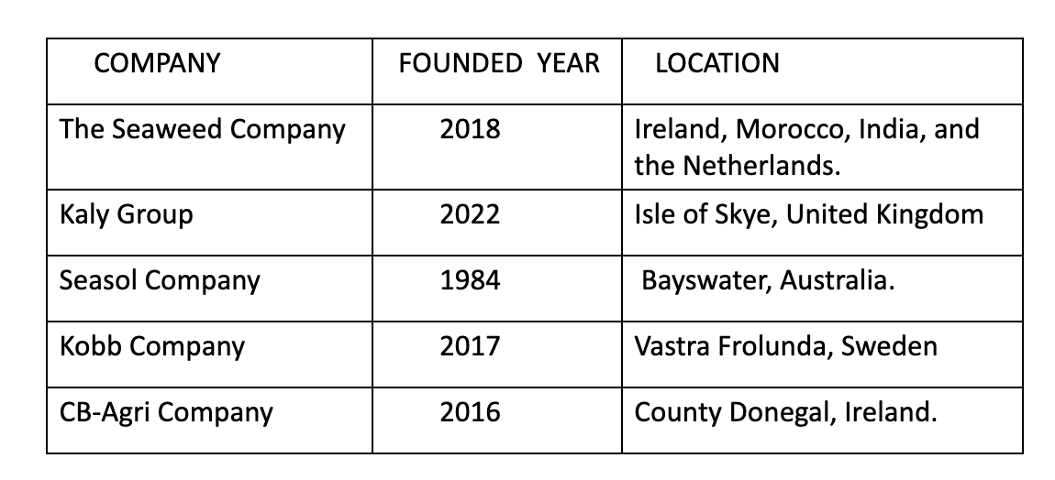

**Table.1., Source**: Onwuchekwa Ikechukwu, Softseaweed major Competitor.

As major competitors of softseaweed, these companies have their unique features that have made them outstanding in the marketplace. This can be found in the table below:

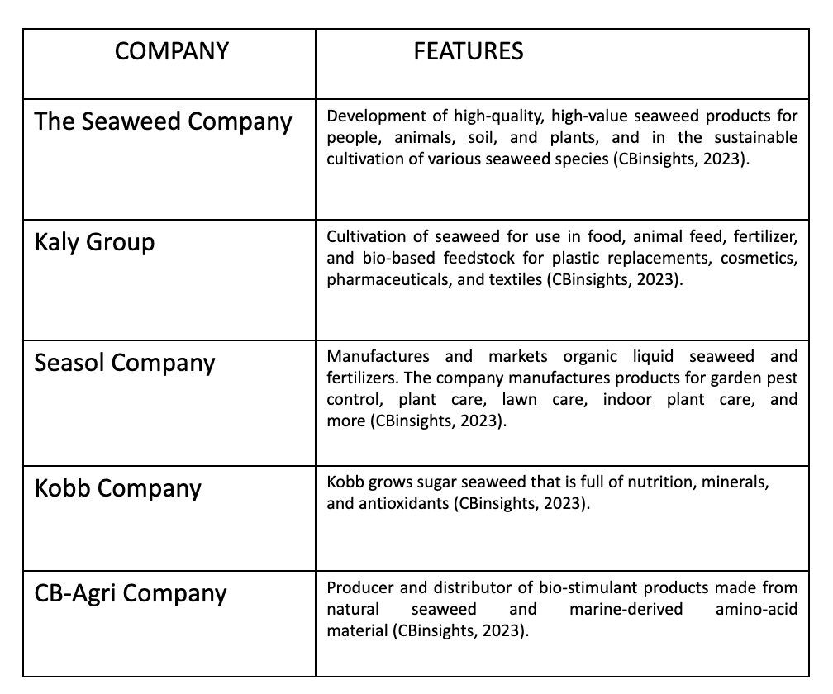

**Table.2., Source:** Onwuchekwa Ikechukwu, Softseaweed major Competitor & features.

## **3.5 Softseaweed’s Current Business Situation**

Softseaweed is a company that was established in 2021 in Norway with an extensive network in the seaweed industry, comprising of five employees, with notable experience in IT and machine learning, business development, engineering and seaweed farming. Softseaweed provides seaweed farmers with a management and monitoring system that gives them access to all the data they need to launch, plan, and grow their business, supported by their AI system, allowing the farmers to fully capitalize on the anticipated 12B Euro market in 2030. They offer a B2B Saas-solution for seaweed farmers to reduce OPEX and increase resource efficiency for the producers through data-collection and analysis with AI-technology.

In order to collect distinctive data sets, softseaweed's business model involves selling a combination of software—the SoftSeaweed Ocean Farm digital platform—and hardware—a set of sensors. Customers must annually renew their software licenses (for advanced ERP software, data collection and storage, dashboard solutions, etc.). The ability to document quality and environmental effects like CO2 capture allows industrial customers to make wise, well-informed decisions. They have a unique buoy with sensors which enables for the easy collection of essential data from the farm-temperature and light level & below sea level, position as well as movements. There is also a digital platform used for information collection from sensors and open-source databases connected to an artificial intelligence platform to help analyze the information. It is necessary to note the softseaweed’s strength and weakness which is shown in the table below:

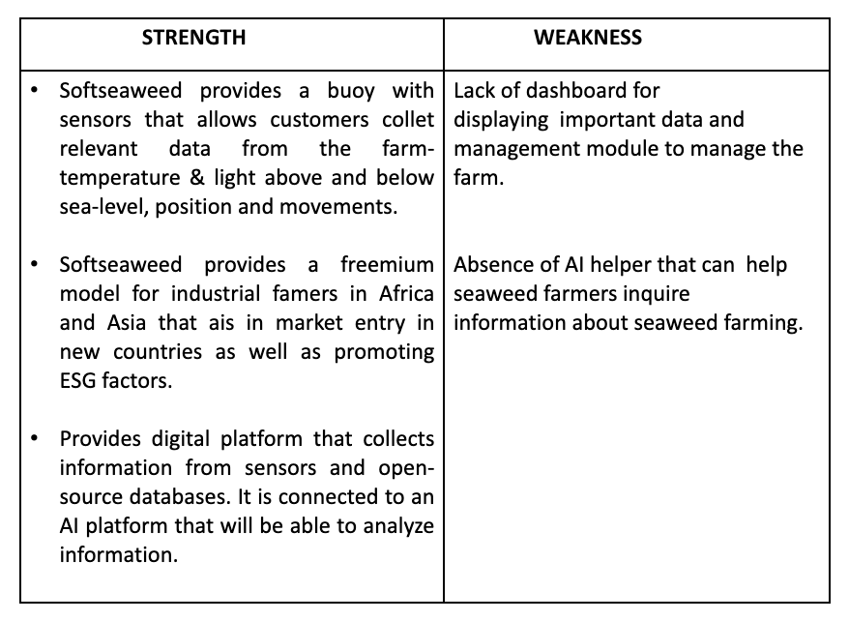

**Table.3.,** Softseaweed’s strength and weakness.

## **3.6. Data Processing**

By identifying the outlier, imputing the missing value, and normalizing the data, the data processing was considered during the data preparation process. I performed a statistical cleaning using the excel software which involves identifying and correcting errors, inconsistencies, and inaccuracies in a dataset to ensure that it's suitable for analysis or further processing. Furthermore, the orange software was used to convert categorical variables (Vegetation_category, Substrate_category, Species, etc.) to numerical variable (Pretnat, A. (2020). This was done using the edit domain widget.

### **3.6.1 Variable Selection**

The orange software is an automated feature engineering tool that automatically detects the variable of a dataset into feature, instances and meta-attribute. There are sixteen variables used for this analysis where the production cost per sample is the independent variable also known as the predictor variable and the remaining variables are all dependent variable. The variable used are shown in the table below:

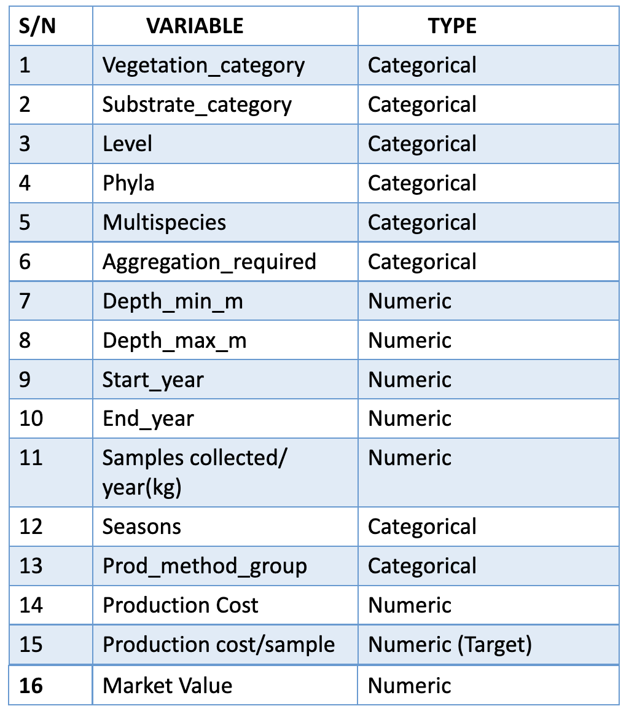

**Table.4.,** Variables used for model prediction

### **3.6.2 Data splitting**

The data was split using a fixed sample size of 10 instances which involves creating a training set for model training and a testing set for evaluating the model's performance. The split ratio was done using the data sampler and the ratio used is shown below:

* Training Set: 70% of 10 instances (7 instances)
* Testing Set: 30% of 10 instances (3 instances)

To avoid data loss, the data was split before cleaning the data, solving overfitting problem which usually causes the model’s performance to be poor. This overfitting problem can be avoided by introducing a cross validation to help reduce the variance and bias problems in composition data set and ensure a good assessment of the performance of the model (Garacia., S, et al, 2015).

### **3.6.3 Linear Regression Model Design Process**

As discussed above, regression model is a simple model that establishes a linear relationship between the predictors for example production cost per sample and continuous outcomes for example market trend. The initial hypothesis, which guides the operation of linear regression algorithms, is the presumption that the two variables under consideration do have a linear relationship. After that, the algorithm tries to determine the values of the coefficient "m" and the intercept "c". Absolute linearity, however, may not always be possible for real-world entities, so the goal is to find the values in such a way that the relationship between x & y is linear to the greatest extent possible, i.e., the resulting line should be as close as possible to all of the provided data points. There are various approaches to optimizing this like using the Ordinary Least sq\. s method.

The response variable can then be predicted using the calculated values (using predictive analytics). The algorithm then determines whether or how strongly the given variables are linearly related to one another, thereby determining whether the assumption or initial hypothesis was correct (Rituparna., G, 2019).

Considering the purpose of this project, I aimed to develop a linear regression model trained using the cross-validation technique. The model was trained using a sample that was distributed with 70:30 percentage ratio of the training and testing sets.

### **3.6.4. Hyperparameter Tuning**

In order to maximize the performance of a machine learning model, hyperparameter tuning entails selecting the ideal set of hyperparameters. Hyperparameters are variables that are not learned from the training data but regulate a variety of learning-related functions (Dong et al. 2018). The grid search algorithm method was used for thee hyperparameter tunning and identified the best combination of hyperparameter value across cross validation score. The figure below shows the linear regression tasks:

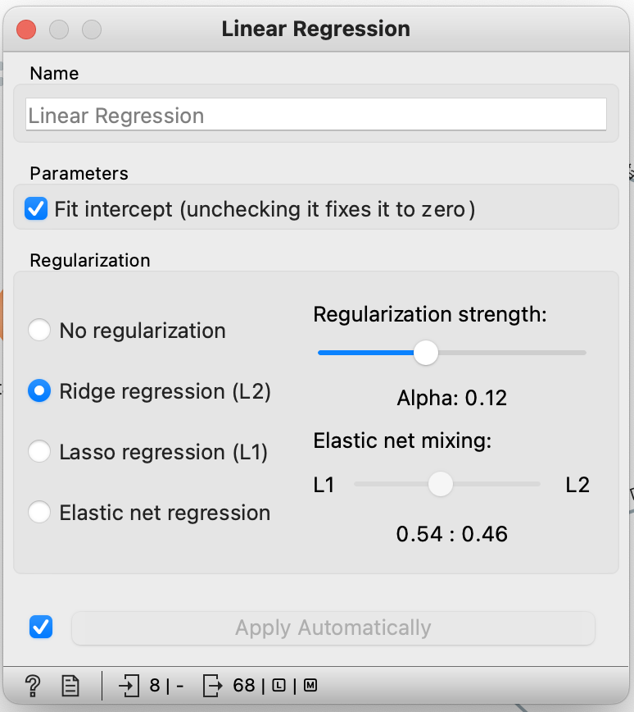

**Fig.11.,** Linear Regression task showing hyperparameter tuning

From the above fig11, the hyperparameter used are shown below:

* **Fit Intercept**

the "fit intercept" is a hyperparameter that determines whether the model should include an intercept term (also known as the bias term) in the regression equation. The intercept represents the value of the dependent variable when all independent variables are set to zero. The fit intercept parameter controls whether the regression line intersects the y-axis at a point other than the origin (0,0).

* **Ridge Regression**

L2 regularization (also known as Ridge regularization) is a technique used to prevent overfitting by adding a penalty term to the linear regression objective function. The penalty term is proportional to the square of the magnitude of the coefficients. L2 regularization encourages the model to find coefficients that are not only a good fit for the data but also small in magnitude.

## **3.7. Model Evaluation**

The model was assessed by comparing the errors made by various time series models in terms of: root mean squared error (RMSE), median absolute error (MAE), mean squared error, and coefficient of determination (R2). R squared (*R*2) is a valuable metric for assessing the fit of regression model and this was used to see how well the model performs putting into consideration cross validation and its number of folds.

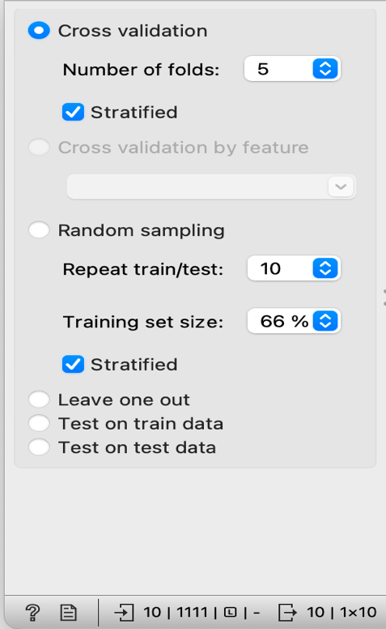

**Fig.12.,** Showing a 5-fold cross validation

From fig12 it is clearly shown that a 5-fold cross validation was used to assess the performance and generalization ability of the model, and this was done through the Test and score widget. Changing the number of cross-validation changed how long the model took to retrain.

# **Chapter 4 – Results and Discussion**

## 4.1. Introduction

This section narrates the findings of the experimental analysis considering the aim of the project which focuses on providing seaweed farmers with practical knowledge to aid in making wise decisions there by helping to reduce production cost and increase revenue through predictive analytics and market trend.

## **4.2. Evaluation of Model Performance**

As previously stated in 3.6.3 on the linear regression model design process, the linear regression technique has been used to build the predictive model in this research. The set of hyperparameter combination has been discussed in fig11 by using the linear regression task in orange. Each hyperparameter setting was trained using different cross-validation but a 5-fold cross- validation was used before the most successful model was chosen for a reliable result.

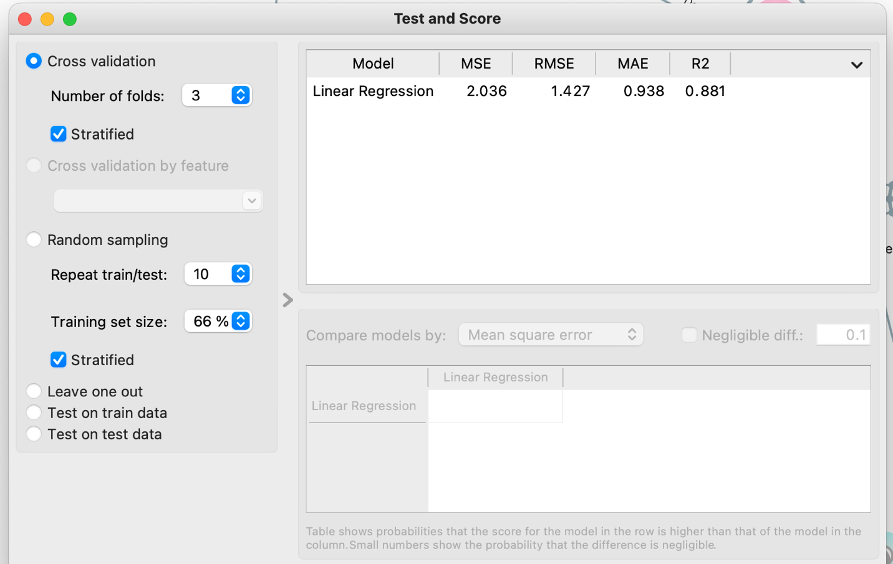

**Fig.13.,** the result of Linear Regression Model using a 3-fold cross- validation

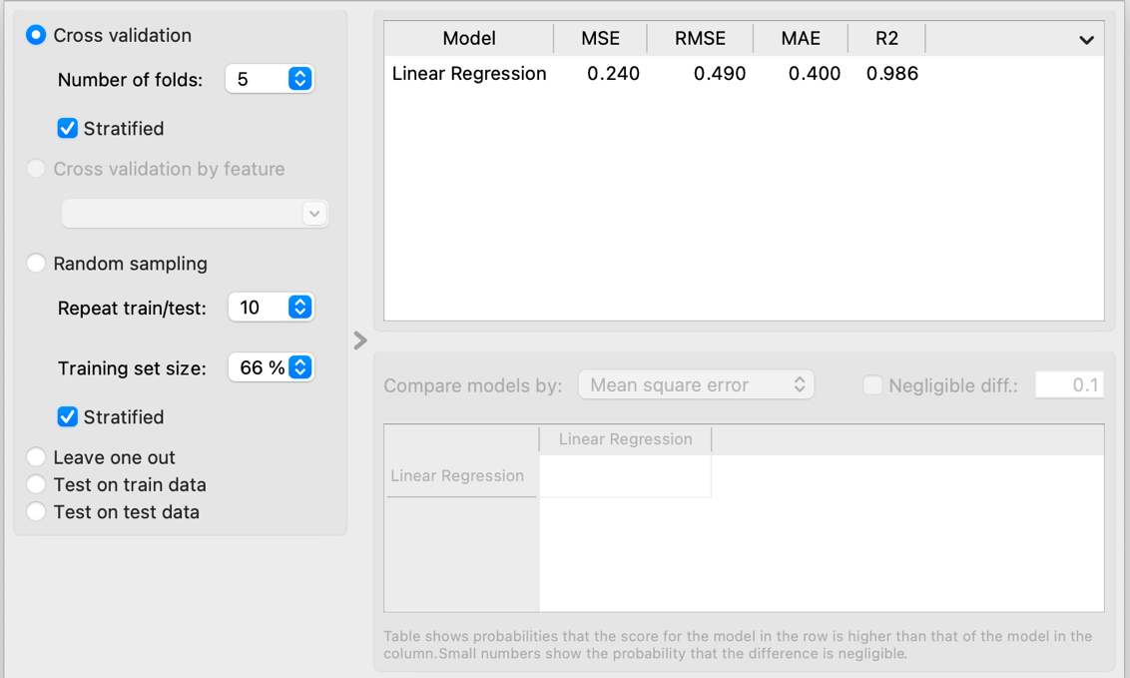

**Fig.14.,** the result of Linear Regression Model on training and testing set across different hyperparameter setting using a 5-fold cross- validation

Fig13 shows the result of the model’s based on the set of parameter combinations used in this experiment. The R squared (R2) shows the accuracy of the model and with an approximate percentage of 98%. This means that the model is a good fit and the 98% of the variability in the "Production cost/sample" which is the target variable can be explained by the independent variables included in the model. In other words, the combination of other dependent variables collectively has a strong influence on the variability in production costs. This can lead to informed decision-making in optimizing seaweed farming and production processes.

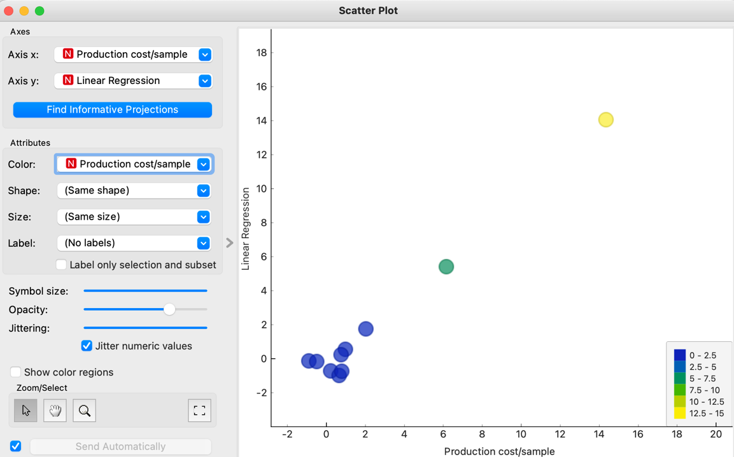

**Fig15.,** Scatter plot showing predicted Model vs real production cost/sample values

Fig14 shows the predicted output plotted against the real production cost/sample values using scatter plot. From the plot, it is seen that both the x and y-axis form an upward-sloping line which indicates a strong positive relationship between the build model and production cost per sample.

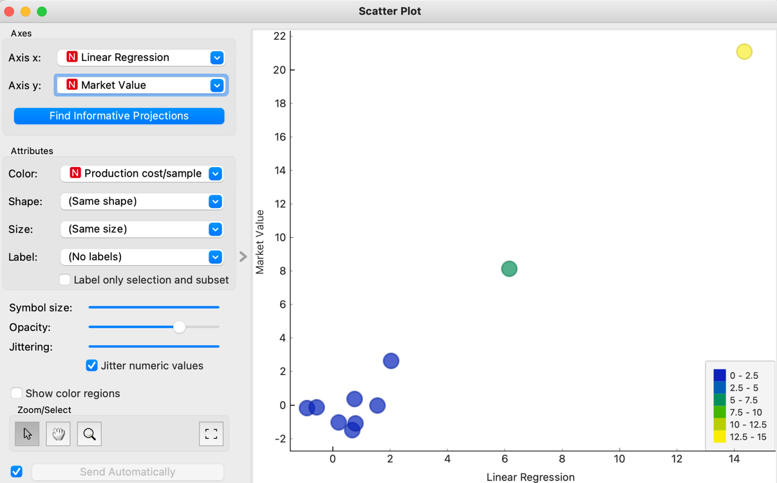

**Fig16.,** Scatter plot showing market value projection using the trained model.

As seen in fig15, is the market value projection using the predictive model. During the cause of the data processing, market value was derived assuming a 50% increase of the production cost value per sample. The formula used for this derivation is shown below:

Market value = X + 0.5X

Where X = production cost per sample.

The above formula used will be dependent on the farmer based on the purpose of this project work. From the above plot it is seen that there is an increase in the market value following the predictive model.

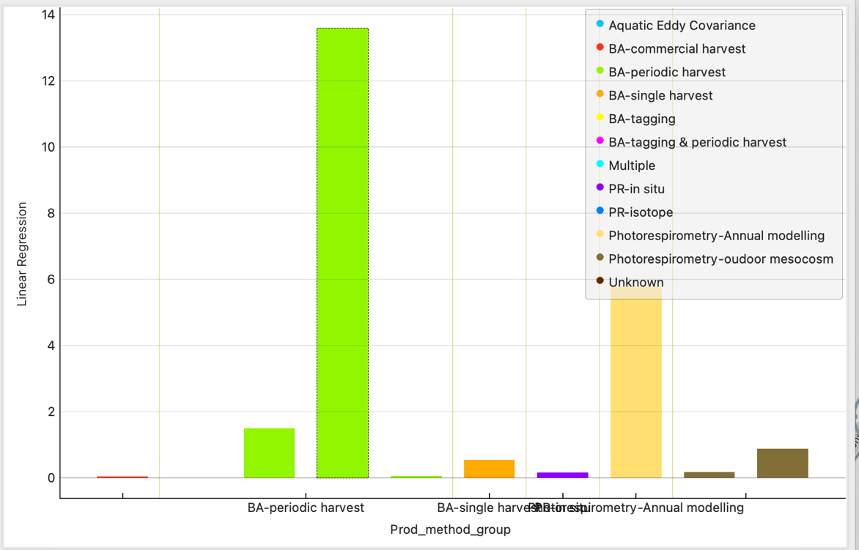

**Fig17.,** Bar plot showing production method using the trained model.

From fig17, it is clearly seen that the most used production method is the biomass accumulation (BA) periodic harvest. Where Biomass accumulation refers to the process of cultivating seaweed with the primary goal of maximizing the overall biomass, or the total weight of the harvested seaweed. This approach focuses on optimizing the growth conditions and cultivation techniques to achieve a high yield of seaweed biomass. It involves various strategies and practices to encourage rapid and healthy growth of seaweed species and the periodic harvest shows the changes in standing biomass which are attributed to growth or losses. A cohort of individuals can be counted, along with their mean weight over time, to estimate production. Other methods include adding up all positive increments, subtracting the maximum and minimum biomass achieved, and summing all positive increments. The above fig 17, shows that there are three BA-periodic method which is as a result of the different species, their substrate_category, production cost and level as seen in Table 5 below.

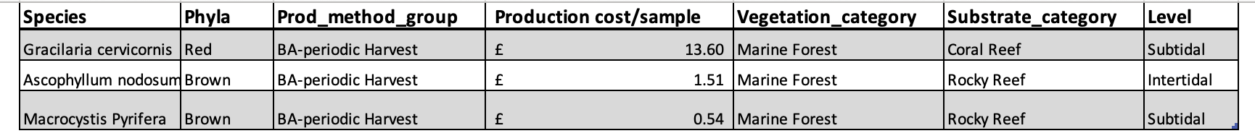

**Table.5.,**

From table 5, it can be deduced that different species have different production cost and the higher the production cost the higher the market value or selling price would be high considering a 50% increase as discussed earlier. Considering the application of these seaweed species as shown in Table6, it shows that these seaweeds are consumable by human, plants and animal.

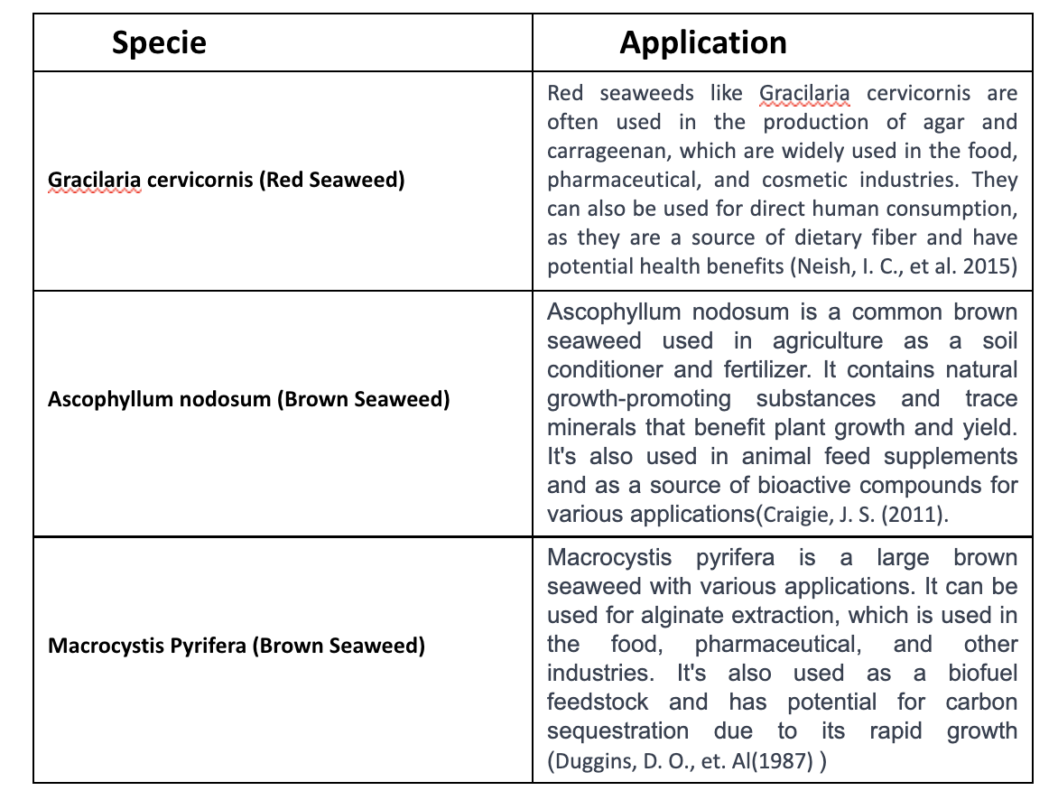

**Table.6.,** Seaweed species and their applications

## **4.3 Cost Benefit Analysis**

This analysis involves the reduction of production cost to generate a higher revenue. Considering the different production cost as seen in Table5, shows that Gracilaria cervicornis has the highest with ∈13.6 even though they all have the same production method. For the production cost to be optimized, we will have to look at their various cultivation methods which will vary based on factors such as infrastructure, labor, materials, and the specific species being cultivated. These cultivation methods are shown in the table below:

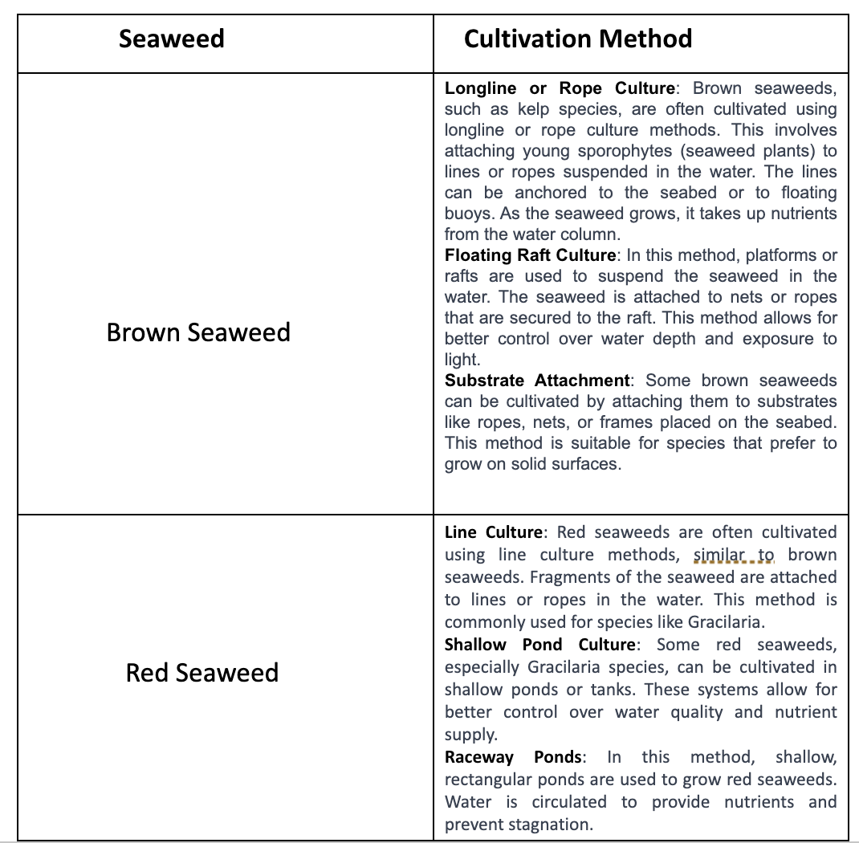

**Table.7.,** Seaweed and their cultivation methods.

From Table7, it is seen that red seaweeds (e.g., Gracilaria species) are cultivated using pond culture and even though these systems allow for better control over water quality and nutrient supply but setting up and maintaining the ponds can involve expenses for lining materials, pumps, pond construction, labor cost and monitoring equipment. For the purpose of this project, these factors can be the reason for the high production cost of the Gracilaria seaweed specie.

This high production cost of the Gracilaria seaweed specie can be reduced and its revenue increased by adapting the line culture method of cultivation as it is generally considered less expensive compared to some other methods. They involve attaching seaweed fragments to lines or ropes suspended in the water. The main costs are associated with the initial setup of the lines or ropes and the labor involved in attaching the seaweed fragments. However, ongoing costs are relatively lower in comparison to methods involving complex infrastructure.

# **Chapter 5 – Conclusion and Recommendation**

## **Conclusion**

The purpose of this project is to optimize seaweed farming production through the strategic integration of predictive analytics and market trend analysis. The project aims to empower seaweed farmers with data-driven insights that enable them to make informed decisions, enhance production efficiency, reduce costs, and capitalize on emerging market opportunities. By leveraging advanced technologies and data analysis, the project seeks to revolutionize the seaweed farming industry, fostering sustainability, economic growth, and innovation. Ultimately, the purpose is to position SoftSeaweed and its clients as leaders in the field by providing actionable solutions that drive the success and competitiveness of seaweed farming operations.

The net primary productivity dataset (NPP) was used for this project. The process of liner regression structural design used was discussed from data preprocessing to model implication. In order to avoid bias in the training process, the five-fold cross validation technique was used in conjunction with the process. Along with the accuracy rate of the training and validation sets, the experimental model results for various hyperparameter settings were reported. The quality of the model was assessed by comparing the errors made by various time series models in terms of: root mean squared error (RMSE), median absolute error (MAE), mean squared error, and coefficient of determination (R2).

The predicted model pointed out the most production method used is the BA-periodic harvest production method considering three different species that used the same harvest method that gave rise to Gracilaria cervicornis specie having the highest production cost when compared to the other species. The best deduced way of reducing this high cost was done considering the cultivation method involved. The findings showed that Gracilaria cervicornis specie of seaweed uses a pond cultivation method that involves setting up ponds, lining materials, pumps and monitoring equipment which is the possible reason for the cost of production. And adapting to the line or rope culture method of cultivation which is generally considered as less expensive will help reduce the cost and increase revenue. The method of seaweed cultivation used plays an important role towards determining the production cost of that seaweed which will in turn affect the yield, production cost and market value.

Following the aim of the project in 1.3 above, the following explains how the newly built model in this project can be used effectively to help seaweed farmers:

1. **Data-Driven Decision Making:**

The predictive model can analyze historical and real-time data from seaweed farming operations. This data can include variables such as production method, harvest method and growth rates. The model can generate predictions and correlations that will guide farmers decisions.

1. **Optimal Growth Condition:**

The model can suggest the optimal growth conditions for different stages of seaweed cultivation. For instance, it can recommend specific water depth levels and light exposure to maximize growth rates and quality.

1. **Market Alignment:**

By integrating market trend data, the model can help align cultivation practices with the specific demands of the market. For example, if there's increasing demand for a certain type of seaweed product, the model can guide your production decisions accordingly.

1. **Risk Mitigation:**

The model can help identify potential risks, such as adverse water quality fluctuations. By being aware of these risks, farmers can take timely actions to mitigate their impact on their farms

1. **Harvest Timing:**

By analyzing growth patterns and historical data, the model can predict the best time to harvest the seaweed. This ensures that farmers harvest at the peak of nutritional value and yield, avoiding both underdeveloped and overripe seaweed.

Furthermore, using the predictive model to reduce production costs and increase revenue in seaweed farming requires a strategic approach that leverages the insights provided by the model. Here's how the model can help achieve these goals:

1. Reducing Production Costs:

**Resource Optimization:** The model has the ability to analyze data on resource consumption (water, nutrients, and energy) and suggest ideal levels for each growth stage. This will help minimize waste and lower the cost of resources.

**Water management:** By examining historical data and weather patterns (considering the season of cultivation), farmers can maximize the use of water. On the timing and length of irrigation, the model can offer suggestions.

**Labor optimization:** Based on growth forecasts, schedule tasks like harvesting using the model. The labor costs can be decreased, and when this is done, timely operations are guaranteed.

1. Increasing Revenue:

**Optimal Harvest Timing:** The model can forecast when to harvest in order to get the highest yield and quality. This makes sure that farmers take advantage of the market's willingness to pay more for high-quality goods.

**Product diversification:** Examine the market to find opportunities for new products. The model can help you decide whether to grow a particular type of seaweed or develop new products with added value.

**Enhancement of Quality:** By preserving ideal growth conditions, the model aids in the production of higher-quality seaweed, which can fetch higher prices on the market.

**Supply Chain Efficiency:** Accurate predictions will help prevent underproduction, ensuring farmers meet market demands and avoiding lost revenue opportunities.

Finally, this project not only addresses the difficulties that seaweed farmers face, but it also creates previously unimaginable opportunities. This initiative is positioned to redefine seaweed farming by fusing predictive analytics, market trend analysis, and technological innovation, driving growth, sustainability, and success in this developing industry.

## **5.2. Limitation**

One possible limitation of this project was the limited data availability and quality. The success of optimizing seaweed farming relies on the quantity and quality of data available for model training and validation and obtaining comprehensive and accurate data from various sources such as buoy sensors, weather forecasts, and market trends was a big challenge. The accuracy of weather data may vary, sensor data may contain noise or missing values, and a variety of uncontrollable factors may have an impact on market trends. Predictive models may be less accurate or provide incomplete insights if there is a lack of historical data for some parameters or inconsistent data collection method.

proper data collection, preprocessing, and augmentation methods are necessary to overcome this limitation. The data quality can be improved by using techniques like imputation, data cleaning, and possibly integrating expert knowledge. Collaborations with pertinent organizations and stakeholders to gain access to larger and more varied datasets may also help to get around this restriction.

## **5.3. Recommendations**

Seaweed aquaculture is a new activity in Europe and substantial research and work is still needed to make it a mainstream activity, with all the correct rules, regulations and standards that will help the industry thrive in a sustainable way. There is a danger that, without data to inform policy, regulators will develop overzealous monitoring and licensing legislation, and thus lay additional burden on the farmers and investors. In order to remedy the data gaps and help seaweed farmers have all the information they need to start and scale their business, softseaweed should:

* **Predictive Growth Models:** Use sensor data to implement predictive models that project growth trajectories. This will empower farmers to optimize cultivation techniques and make informed decisions based on real-time insights.
* **Dashboard for Real-Time Monitoring:** Create a user-friendly dashboard to track farm conditions in real-time. With the help of this tool, farmers will receive actionable insights that will enable quick interventions and increase productivity.
* **Integration of Market Intelligence:** By incorporating market trend analysis into the SoftSeaweed platform, farmers will be able to match their production strategies with changing consumer demands, improving their ability to compete in the market.
* **Knowledge Sharing Hub:** Establish a collaborative platform for farmers to exchange best practices and insights, fostering a community-driven approach to learning and improvement.
* **User-Centric Interface:** Ensure the solutions are user-friendly, enabling farmers of all expertise levels to harness the power of predictive analytics and market trend analysis.
* **Brand Reputation:** Consistently delivering high-quality seaweed management software and sensor packages can enhance softseawed’s brand reputation and lead to customer loyalty, resulting in repeat business and positive word-of-mouth.

### **5.3.1. Addressing key risk issues and sustainability issues**

### **5.3.2. Key Risk Issues & solution:**

1. Data Security and Privacy

Data breaches and privacy issues can result from the collection and storage of data, particularly sensitive market-related data. In addition to adhering to data protection laws, SoftSeaweed can implement robust encryption and secure data storage procedures. Penetration testing and routine security audits can guarantee data security.

1. Model Reliability

Making decisions based on inaccurate predictive models developed from incomplete or noisy data can be detrimental. Deep data preprocessing, validation, and model assessment should be prioritized by SoftSeaweed. Reliability can be improved by frequently updating models using new data.

1. Technical Challenges

Infrastructure for advanced analytics and machine learning can be difficult to create and is prone to technical problems. SoftSeaweed ought to keep a talented and multicultural technical staff. Challenges can be overcome by working with technology experts and investing in ongoing education.

1. Dependency on External Data

It's possible for weather forecasts and market trends to be inaccurate or unavailable if only third-parties are relied on for data sources.

### **5.3.3. Sustainability Issues & Solution:**

1. Environmental Impact Mitigation

Unsustainable farming methods can have a negative impact on biodiversity and marine ecosystems. Environmental impact studies should be done, SoftSeaweed should provide sustainable seaweed cultivation guidelines, and it should educate farmers about ethical farming practices.

1. Resource Management

Overuse of resources such as water, nutrients, and energy can harm the environment and deplete available supplies. Through their platform, SoftSeaweed can monitor resources in real-time, implement resource-efficient farming techniques, and provide recommendations for their best use.

1. Long-Term Viability and Adaptation

Without modification, this project's effectiveness might diminish over time. To maintain long-term relevance, SoftSeaweed must regularly update their predictive models, incorporate fresh data sources, and keep abreast of cutting-edge technologies.

1. Equitable Benefit Distribution

Predictive analytics' advantages might unfairly favor larger farms while neglecting small-scale farmers. Small-scale farmers should receive assistance from SoftSeaweed in the form of training and support, and the company should also create forums for knowledge exchange and make sure that all types of farmers can use their platform.

1. Transparency and Communication

Mistrust among stakeholders may result from a lack of transparency. SoftSeaweed needs to be transparent about their methods, results, and any potential drawbacks. Building trust can result from consistent engagement with stakeholders.

The proposed solutions have the potential to reshape the seaweed farming landscape. By integrating advanced analytics cultivation method and market insights, this project will empower farmers to optimize their production processes, reduce costs, and capitalize on emerging market trends. Through this endeavor, SoftSeaweed and its clients can contribute to a more sustainable and prosperous seaweed farming industry, establishing themselves as pioneers in innovative farming practices.

# **Chapter 6- References**

Banyuriatiga. C., Dwidjono, H., Lestari, Ri., (2017). Production efficiency of seaweed farming in tarakan north borneo. [Accessed: 30 July 2023].

Beca-Carretero, P., Gómez-Gesteira, M., Santos, F., Torres-López, S., & DeCastro, M. (2020). Use of Remotely Sensed Oceanographic Data for the Optimization of Commercial Seaweed Aquaculture Sites. Remote Sensing, 12(2), 327.

Bird, K.T. and Benson, P.H. (1987). *Seaweed Cultivation for Renewable Resources*.

Buck, B. H., & Buchholz, C. M. (2004). The Utilisation of Kelp (Laminariales, Phaeophyceae) for Marine Larviculture: A Review. Aquaculture, 236(1-4), 147-165.

CBInsights (2023) SoftSeaweed’s alternatives and competitors. Available: https://www.cbinsights.com/company/softseaweed/alternatives-competitors [Accessed: 15 August 2023].

Chopin Thierry., Yarish Charles., Sharp Glyn. (2017). Integrated multi-trophic aquaculture: Guidelines and tools for implementation. FAO Fisheries and Aquaculture Technical Paper No. 623. Rome.

Craigie, J. S. (2011). Seaweed extract stimuli in plant science and agriculture. Journal of Applied Phycology, 23(3), 371-393.

Dong, X., Shen, J., Wang, W., Liu, Y., Shao, L., & Porikli, F. (2018). Hyperparameter optimization for tracking with continuous deep q-learning. In Proceedings of the IEEE conference on computer vision and pattern recognition (pp. 518-527).

Duggins, D. O., Simenstad, C. A., & Estes, J. A. (1989). Magnification of secondary production by kelp detritus in coastal marine ecosystems. Science, 245(4914), 170-173.

Food and Agriculture Organization (FAO). (2012). Seaweed Farming: Sustainable Production of Food and Feed, Chemicals, and Energy. [Accessed: 8 July 2023].

Food and Agriculture Organization (FAO) of the United Nations. (2020). The state of world fisheries and aquaculture 2020. Retrieved from  http://www.fao.org/3/ca9229en/CA9229EN.pdf [Google Scholar]

García, S., Luengo, J., & Herrera, F. (2015). Data preprocessing in data mining (pp. 195-243). Cham, Switzerland: Springer International Publishing.

Gentry, R. R., Kadin, M., Cioce, F., Paytan, A., & Siegel, D. A. (2017). Seaweed cultivation on the rise in Europe: A review of its status, environmental impacts, and future prospects. Frontiers in Marine Science, 4, 18.

Grand View Research. (2021). Seaweed Market Size, Share & Trends Analysis Report by Product (Red, Brown, Green), by Application (Human Food, Animal Feed), by Region (North America, Europe, APAC, CSA, MEA), and Segment Forecasts, 2021-2028.

Guiry, M. D., & Guiry, G. M. (Eds.). (2019). Seaweeds: Edible, Available, and Sustainable. [Accessed: 8 July 2023].

Hughes, A. D., Gribben, P. E., & Zhang, X. (2019). Seaweed aquaculture: A pathway to sustainability in the face of global change? Oceanography and Marine Biology: An Annual Review, 57, 1-79.

Kondo, M., Patra, P.K., Sitch, S., Friedlingstein, P., Poulter, B., Chevallier, F., Ciais, P., Canadell, J.G., Bastos, A., Lauerwald, R., Calle, L., Ichii, K., Anthoni, P., Arneth, A., Haverd, V., Jain, A.K., Kato, E., Kautz, M., Law, R.M. and Lienert, S. (2019). State of the science in reconciling top‐down and bottom‐up approaches for terrestrial CO 2 budget. *Global Change Biology*, 26(3), pp.1068–1084. Doi; https://doi.org/10.1111/gcb.14917.

Kraan, S. (2013). Seaweed Farming in Europe: Potential, Opportunities and Challenges. In European Aquaculture Society Special Publication (Vol. 63, pp. 114-117).

Liu, F., Liu, G., Chen, X., Zhang, X., & Xu, Y. (2021). The economic performance of seaweed farming: An empirical analysis of the macroeconomic benefits. Marine Policy, 123, 104358.

Mohseni, E. and Tang, W. (2021) Parametric analysis and optimization of energy efficiency of a lightweight building integrated with different configurations and types of PCM. Renewable Energy 168, pp. 865–877. Available at: https://doi.org/10.1016/j.renene.2020.12.112.

Mordor Intelligence Research & Advisory. (2023, June). Commercial Seaweed Market Size & Share Analysis - Growth Trends & Forecasts (2023 - 2028). Mordor Intelligence. Retrieved August 6, 2023, from https://www.mordorintelligence.com/industry-reports/commercial-seaweed-market?gclid=Cj0KCQjwib2mBhDWARIsAPZUn_m_iuAbIfG7uaLLueFhXgIopS2dJeKf22eFoMFn1yG4DGFnTvsBkVQaAqfFEALw_wcB

Neish, I. C., Longstaff, B. J., & Pitre, F. E. (2015). Carrageenophyte (Gigartinales, Rhodophyta) genetic diversity, phylogeography, and carrageenan content in the Atlantic Canadian Arctic. Phycologia, 54(6), 653-664.

Neori, A. et al. (2004) ‘Integrated aquaculture: Rationale, evolution and state of the art emphasizing seaweed biofiltration in modern mariculture’, Aquaculture, 231(1–4), pp. 361–391. doi:10.1016/j.aquaculture.2003.11.015.

Neori, A. (2007). Essential role of seaweed cultivation in integrated multi-trophic aquaculture farms for global expansion of mariculture: an analysis. *Journal of Applied Phycology*, 20(5), pp.567–570. Doi; https://doi.org/10.1007/s10811-007-9206-3.

Pessarrodona, A., Filbee-Dexter, K., Krumhansl, K.A. et al. A global dataset of seaweed net primary productivity. Sci Data 9, 484 (2022). https://doi.org/10.1038/s41597-022-01554-5

Pretnat, A. (2020) Managing data with edit domain, Orange Data Mining - Data Mining. Available at A https://orangedatamining.com/blog/2020/2020-06-19-edit-domain/ (Accessed: 23 August 2023)

Polaris Market Research & amp; Consulting LLP (2023) Global seaweed protein market size/share forecasted to reach USD 1,407.41 million by 2032, at 11.3% CAGR: Polaris Market Research, GlobeNewswire News Room. Available at: https://www.globenewswire.com/news-release/2023/07/06/2700519/0/en/Global-Seaweed-Protein-Market-Size-Share-Forecasted-to-Reach-USD-1-407-41-Million-By-2032-at-11-3-CAGR-Polaris-Market-Research.html (Accessed: 14 July 2023).

Softseaweed (2023) SoftSeaweed. Available at: https://softseaweed.com/ (Accessed: 15 August 2023).

Renaud, P., & Luong-Van, J. (2009). Seaweed: A User's Guide. [Accessed: 8 July 2023].

Ridler, N., Wowchuk, M., Robinson, B., Barrington, K., Chopin, T., Robinson, S., Page, F., Reid, G., Szemerda, M., Sewuster, J. and Boyne-Travis, S. (2007). INTEGRATED MULTI − TROPHIC AQUACULTURE (IMTA): A POTENTIAL STRATEGIC CHOICE FOR FARMERS. *Aquaculture Economics & Management*, 11(1), pp.99–110. Doi; https://doi.org/10.1080/13657300701202767.

Rituparna., Gupta, (2019) Designing Linear Regression from scratch. Available at: https://medium.com/swlh/designing-linear-regression-from-scratch-ed542bf06943 (Accessed: 24 August 2023).

Troell, M., Joyce, A., Chopin, T., Neori, A., Buschmann, A.H. and Fang, J.-G. (2009) Ecological Engineering in aquaculture — potential for integrated multi-trophic aquaculture (IMTA) in Marine Offshore Systems. Aquaculture, 297 (1–4), pp. 1–9. 10.1016/j.aquaculture.2009.09.010.

‌

Zhang, L., Liao, W., Huang, Y., Wen, Y., Chu, Y. and Zhao, C. (2022) Global seaweed farming and processing in the past 20&nbsp; years - food production, processing and Nutrition. BioMed Central. BioMed Central, 2 November. Available: https://fppn.biomedcentral.com/articles/10.1186/s43014-022-00103-2 - Fig4 [Accessed: 14 July 2023].

## **6.1 Ethics approval (letter) Certificate Attached**

